

08

Fall

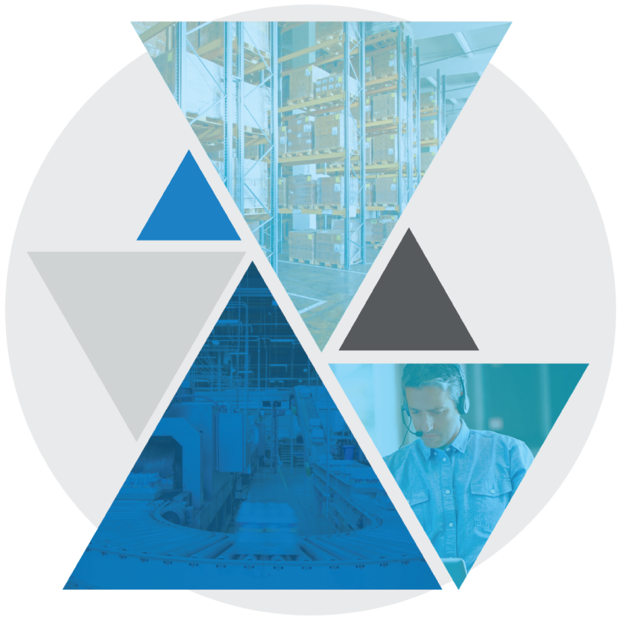

**Test Case: BASE-YRD-1050**

**Web Outbound Trailer Check In with Safety Check**

Table of Contents

Web Outbound Trailer Check In with Safety Check 3

Test Case Setup 3

Test Case Cleanup 3

Test Case Prerequisites and Assumptions 4

Test Case Examples 4

Test Case Configurations 5

Test Case Verification Approach 5

Test Case Specification 5

Web Outbound Trailer Check In with Safety Check

This document documents the test case instructions for the BASE-YRD-1050 Bundle Test Case implementing Web Outbound Trailer Check In with Safety Check.

**Please note**: The inputs used in these test case specifications (defined in the input CSV files or Datastore) are relative to our testing warehouse environment and are provided as examples. These inputs should be substituted with valid inputs relative to your WMS environment.

Test Case Setup

* Test Case Background function will run the standard set of setup scenarios for the bundle.
* Test Case Dataset
  + Creates a trailer if applicable
  + Checks in the trailer to the specified dock location

Test Case Cleanup

* The Test Case After Scenario will run the standard cleanup actions for the bundle.   
  **NOTE:** This including logging out of all interfaces (Terminal and Web).
* Data created during dataset creation and execution is cleaned up.

Test Case Prerequisites and Assumptions

* Dock door is available for check in
* Process assumes check in without appointment
* Trailer safety check workflow is enabled

Test Case Examples

This Test Case will only perform Web Outbound Trailer Check In with Safety Check and will not perform any other examples of this function.

Test Case Configurations

The Test Case will be run in the following test configurations:

* Blue Yonder Web UI
  + Google Chrome
  + Microsoft Edge

Test Case Verification Approach

This test will verify screen data in-line within the test step sections.

It will also Utilize a MSQL WMS query to validate that the anticipated end state was reached.

Test Case Specification

|  |  |
| --- | --- |
| **Test Case:** BASE-YRD-1050 Web Outbound Trailer Check In with Safety Check | **Description:** Web Outbound Trailer Check In with Safety Check **Functional Area:** Outbound **Test Case Type:** Regression **Dataset:** NA **Test Case Inputs:** Test Case Inputs/BASE-YRD-1050.csv  **Duration:** 1.5 minutes |

|  |  |
| --- | --- |
| **Steps, Actions, and Expected Results** | **Supporting information and/or Affected Data** |
| **Step 1**: Sign into the Web UI using your relevant Username and Password  **Actions**:   * Enter Username and Password * Click on the **Sign In** button   **Expected Results**:   * User successfully logs on to web |  |

|  |  |
| --- | --- |
| **Step 2**: Search for *Transport Equipment* Web screen  **Actions**:   * Type ‘Transport Equipment’ in JDA search field and press ENTER   **Expected Results**:   * Relevant pages are returned from the search. |  |

|  |  |
| --- | --- |
| **Step 3**: Navigate to *Receiving Transport Equipment* Web page  **Actions**:   * Select **Receiving -> Transport Equipment**   **Expected Results**:   * *Transport Equipment* screen is open now |  |

|  |  |
| --- | --- |
| **Step 4**: Navigate to the Add Transport Equipment windows  **Actions**:   * Click into the **Actions** menu * Click on the **Add Transport equipment** Option   **Expected Results**:   * *Add Transport Equipment* windows is now open |  |

|  |  |
| --- | --- |
| **Step 5**: Insert relevant Equipment attributes  **Actions**:   * Enter in the following data (defined from input file): * Equipment Number: TRK1050 * Carrier: CYCCAR1 * Use: Shipping * Type: Truck/Transport Equipment * Exit the window   **Expected Results**:   * *Transport Equipment* screen now includes TRK1050 |  |

|  |  |
| --- | --- |
| **Step 6**: Search for Transport Equipment Web screen  **Actions**:   * Type ‘Transport Equipment’ in JDA search field and press ENTER   **Expected Results**:   * Relevant pages are returned from the search. |  |

|  |  |
| --- | --- |
| **Step 7**: Navigate to *Transport Equipment* Web page  **Actions**:   * Select **Receiving -> Transport Equipment**   **Expected Results**:   * *Transport Equipment* screen is open now |  |

|  |  |
| --- | --- |
| **Step 8**: Search for trailer  **Actions**:   * Click the Quick Filters search bar * Type ‘TRK1050’ (defined in input file) * Press ENTER   **Expected Results**:   * TRK1050 is now the only Transport Equipment featured in the list |  |

|  |  |
| --- | --- |
| **Step 9**: Search for Check In  **Actions**:   * Type ‘Check In’ in JDA search field * Press ENTER   **Expected Results**:   * *Check In* page is now visable |  |

|  |  |
| --- | --- |
| **Step 10**: Search for desired Transport Equipment  **Actions**:   * Type ‘TRK1050’ in the *Transport Equipment* search bar (defined in input file) * Press ENTER   **Expected Results**:   * Check In options for TRK1050 are now visable |  |

|  |  |
| --- | --- |
| **Step 11**: Check In trailer  **Actions**:   * Select desired dock location *CYC_SDCK_005* from within the Locations list (defined in input file) * Click the **Check In** button   **Expected Results**:   * *Check In Successful* pop up is now visable |  |

|  |  |
| --- | --- |
| **Step 12**: Search for Transport Equipment Web screen  **Actions**:   * Type ‘Transport Equipment’ in JDA search filed and press ENTER   **Expected Results**:   * Relevant pages are returned from the search. |  |
| **Step 13**: Navigate to *Transport Equipment* Web page  **Actions**:   * Select **Receiving -> Transport Equipment**   **Expected Results**:   * *Transport Equipment* screen is open now |  |

|  |  |
| --- | --- |
| **Step 14**: Search for relevant transport equipment  **Actions**:   * Enter the transport equipment number in filter field (defined in input file) * Press ENTER   **Expected Results**:   * The transport equipment details will show up on the screen |  |

|  |  |
| --- | --- |
| **Step 15**: Search for trailer  **Actions**:   * Click the Quick Filters search bar * Type ‘TRK1050’ (defined in input file) * Press ENTER   **Expected Results**:   * TRK1050 is now featured in the list |  |

|  |  |
| --- | --- |
| **Step 16**: Perform Safety Check on equipment  **Actions**:   * Click the **Safety** button below the desired equipment * Click the **Perform Safety Check** button in pop up   **Expected Results**:   * The *Safety Checks* window is now open |  |

|  |  |
| --- | --- |
| **Step 17**: Perform Safety Check inputs  **Actions**:   * Click the four **Pass** buttons shown in the window * Exit the window by pressing the ESC   **Expected Results**:   * Transport Equipment page is now visable |  |

|  |  |
| --- | --- |
| **Step 18**: Remove and reapply search filter  **Actions**:   * Click the X on the right side of the Ad-Hoc filter * Re enter the transport equipment number in filter field * Press ENTER   **Expected Results**:   * The Transport equipment details will show up on the screen |  |

|  |  |
| --- | --- |
| **Final State:** Verify Safety Check status as Passed  Standard test verification and log off functions are performed |  |